AI-Based Personal Disaster Assistant

A Project Report Presented to
The Faculty of the College of Engineering
San Jose State University In Partial Fulfillment
Of the Requirements for the Degree
Master of Science in Software Engineering

By
Nitya Reddy Yerram, Pratik Kamanahalli Mallikarjuna, Priyanka Ajit Mutha, Sheetal Chandrabali Yadav
May 2026

Copyright © 2026
Nitya Reddy Yerram, Pratik Kamanahalli Mallikarjuna, Priyanka Ajit Mutha, Sheetal Chandrabali Yadav
ALL RIGHTS RESERVED

APPROVED

[Andrew Bond], Project Advisor
[Program Director’s Name], Director, MS Software Engineering

ABSTRACT
AI-Based Personal Disaster Assistant
By Nitya Reddy Yerram, Pratik Kamanahalli Mallikarjuna, Priyanka Ajit Mutha, Sheetal Chandrabali Yadav

Climate-driven natural hazards such as floods, heatwaves, earthquakes, wildfires, and cyclones are increasing in frequency and severity worldwide. Existing early-warning systems are fragmented, hazard-specific, and designed for large agencies rather than individuals, leaving communities without personalized and actionable guidance. This project develops a mobile-first AI-Based Personal Disaster Assistant that combines real-time environmental intelligence from NOAA HRRR, Copernicus EFAS/GloFAS, NASA, IMD, USGS, and FEMA with advanced machine learning models to deliver hyperlocal, predictive alerts at 250m to 1km spatial resolution. A ConvLSTM/CNN-LSTM architecture forecasts flood inundation probability and depth; a CNN/regression model estimates street-level heat index gradients. Predictions are fused with geospatial layers in PostgreSQL/PostGIS and served via FastAPI endpoints on AWS Lambda.
The iOS application, built with SwiftUI and MapLibre SDK, renders color- coded hazard overlays, computes hazard-aware evacuation routes using pgRouting and OSM road graphs, displays nearby shelter availability, and delivers push notifications via APNs and AWS SNS. An integrated AI chatbot powered by Google Gemini provides users with context-aware disaster guidance. The system incorporates offline tile caching, AES-256 encryption, TLS 1.3 data transit security, and MHEWS-aligned impact- based alerting.

Acknowledgments
The authors are deeply indebted to Professor Andrew Bond for his invaluable comments and assistance in the preparation of this study.

v

Table of Contents
Chapter 1. Project Overview 1
Introduction 1
Proposed Areas of Study and Academic Contribution 2
Current State of the Art 3
Chapter 2. Project Architecture 4
Introduction 4
Architecture Subsystems 6
Chapter 3. Technology Descriptions 8
Client Technologies 8
Middle-Tier Technologies 9
Data-Tier Technologies 10
Chapter 4. Project Design Error! Bookmark not defined.
Client Design Error! Bookmark not defined.
Middle-Tier Design 13
Data-Tier Design 13
Chapter 5. Project Implementation Error! Bookmark not defined.
Client Implementation 14Error! Bookmark not defined.
Middle-Tier Implementation 15Error! Bookmark not defined.
Data-Tier Implementation 16Error! Bookmark not defined.
Chapter 6. Testing and Verification Error! Bookmark not defined.
Chapter 7. Performance and Benchmarks Error! Bookmark not defined.
Chapter 8. Deployment, Operations, Maintenance Error! Bookmark not defined.
Chapter 9. Summary, Conclusions, and Recommendations Error! Bookmark not
defined.
Summary Error! Bookmark not defined.
Conclusions Error! Bookmark not defined.
Recommendations for Further Research Error! Bookmark not defined.
Glossary 21
References 29
Appendices 30
Appendix A 30
vi

List of Figures
List of Figures
Figure 1. High-Level System Architecture and Data Flow Pipeline for AI- Based Personal
Disaster Assistant………………………………………………………………………
...7
Figure 2. Entity-Relationship Model showing User, Location, Disaster Event, Shelter,
Route, and Prediction entities with key relationships 10

vii

List of Tables

viii

Chapter 1. Project Overview
Introduction
Climate-driven natural hazards—such as floods, heatwaves, earthquakes, wildfires, and cyclones—are increasing in frequency and severity worldwide. Traditional early-warning systems, while effective at large geographic scales, tend to lack the hyperlocal precision, realtime adaptability, and personalized guidance necessary for individuals to make timely, safetycritical
decisions. Existing disaster notification frameworks often rely on regional thresholds, static impact assumptions, delayed model updates, and uniform messaging that fails to account for a user’s exact location, vulnerability, or available safe routes. These limitations are especially problematic during rapidly evolving urban flashfloods, localized heat islands, or geophysical events where risks vary across street-level micro-zones.
To address this gap, this project proposes an AI-Based Personal Disaster Assistant—a mobile-first platform that combines real-time environmental intelligence, machine-learning prediction models, geospatial analytics, and personalized alert delivery. The system ingests
live data from global environmental agencies (NOAA HRRR, Copernicus EFAS/GloFAS, NASA, IMD, USGS, FEMA) and transforms them into localized risk predictions at 250 m – 1 km scale. The intelligence core leverages spatiotemporal deep learning models (ConvLSTM,
CNN-LSTM) for flood risk forecasting and ML-based regression/CNN approaches for heat index prediction. These predictions are fused with geospatial layers stored in PostGIS to provide an intuitive color-coded risk map, accompanied by actionable notifications aligned
with the user’s home, work, and essential locations. Beyond prediction, the platform introduces a proactive safety framework through hazardaware routing. Using OSM road graphs, PostGIS, pgRouting or Valhalla, the application can recommend safe paths that avoid high-risk corridors. Data caching, offline map tiles, and privacy-preserving design ensure operational reliability during network outages and sensitive disaster contexts.

Given the intensifying impact of climate hazards and the critical need for real-time, hyperlocal decision intelligence, this project seeks to provide a scalable, trustworthy, and personalized multi-hazard assistant that supports community resilience and individual safety.
Proposed Areas of Study and Academic Contribution

This project integrates concepts from environmental modeling, artificial intelligence and machine learning, geospatial analytics, mobile application development, and distributed cloud systems to build a personalized disaster intelligence platform. The system employs spatiotemporal deep learning models such as ConvLSTM and CNN-LSTM to forecast short-range flood probabilities using meteorological and satellite datasets, while regression- based models estimate heat-risk levels from environmental variables including temperature, humidity, and solar radiation. A multi-hazard data integration framework continuously ingests and harmonizes information from agencies such as NOAA, Copernicus, NASA, USGS, IMD, and FEMA through cloud-based ETL pipelines on AWS, enabling real-time risk analysis and monitoring. Geospatial intelligence techniques combine hazard layers with OpenStreetMap road networks to generate safety-optimized evacuation routes using PostGIS and routing engines like pgRouting or Valhalla. The system also follows Multi-Hazard Early Warning System (MHEWS) principles by providing impact-based, personalized alerts with clear time windows and confidence indicators for user-defined locations such as home or workplace. To ensure responsible deployment, the platform incorporates privacy-preserving mechanisms including coarse-resolution location storage and strong encryption (AES-256 and TLS 1.3). Overall, this work demonstrates the feasibility of integrating environmental sensing, predictive modeling, geospatial analytics, and mobile interfaces to deliver hyperlocal disaster guidance that improves preparedness, situational awareness, and community resilience.

Current State of the Art

The current state of research and practice in disaster early-warning systems shows significant advancements through the use of open environmental data, satellite sensing, spatiotemporal deep learning, and distributed mobile alerting technologies. Recent academic studies demonstrate that models such as ConvLSTM and CNN-LSTM outperform traditional LSTM approaches for flood prediction by capturing both spatial hydrological patterns and temporal storm dynamics, while SAR Sentinel-1 satellite imagery enables reliable all-weather flood detection. Advances in remote sensing and machine learning have also enabled sub-kilometer urban heat-risk estimation and improved hazard monitoring. At the policy level, frameworks such as Multi-Hazard Early Warning Systems (MHEWS) emphasize that effective warnings must be impact-based, localized, and accessible to diverse populations. From an engineering perspective, modern disaster-intelligence systems integrate high-resolution weather forecasts (e.g., NOAA HRRR), hydrological models such as EFAS/GloFAS, geospatial databases like PostGIS, and mobile mapping technologies to support real-time hazard monitoring and alert dissemination. However, many existing systems still face limitations, including coarse spatial predictions, generic non- personalized alerts, lack of hazard-aware evacuation routing, vulnerability to connectivity disruptions, and inconsistent privacy protections. These gaps highlight the need for hyperlocal risk prediction, personalized alerting, and resilient mobile platforms—capabilities that this project aims to address through integrated multi-hazard modeling, geospatial intelligence, and user- centric disaster guidance.

Chapter 2. Project Architecture
Introduction

The architecture of the AI-Based Personal Disaster Assistant follows a multi-tier, service-oriented design that ensures scalability, modularity, and reliable real-time operation during disaster events. The system consists of four main layers: the mobile client, backend services, machine learning inference modules, and the geospatial data layer. Environmental data from global sources such as NOAA HRRR, Copernicus EFAS/GloFAS, NASA, USGS, IMD, and FEMA are periodically ingested through ETL pipelines to generate hyperlocal flood and heat-risk predictions. These outputs are stored in a PostGIS-enabled PostgreSQL database and delivered to the iOS application via FastAPI endpoints deployed on AWS Lambda. The mobile application visualizes hazard overlays using MapLibre, sends alerts through APNs, and supports offline map access for low-connectivity scenarios. This layered architecture integrates environmental intelligence, predictive modeling, and mobile visualization to deliver secure, personalized disaster alerts while providing a scalable foundation for future multi-hazard analytics and decision-support systems.

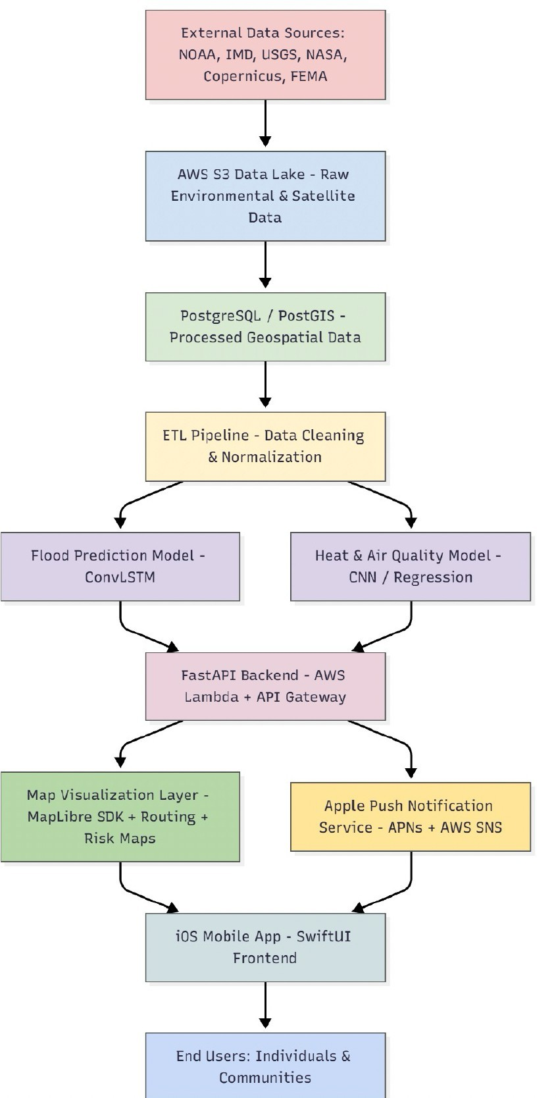

Architecture Subsystems

The system is structured into four integrated subsystems that collectively support data processing, prediction, alerting, and user interaction. The frontend layer, implemented as an iOS mobile application using SwiftUI, MapLibre SDK, and CoreLocation, handles user interaction, hazard visualization, and alert delivery. It allows users to define important locations such as home or work, view color-coded flood and heat risk overlays, access evacuation routes and nearby shelters, and receive hazard alerts through Apple Push Notification Service (APNs), while also supporting offline map access through cached vector tiles.
The backend service layer, built with FastAPI and deployed on AWS Lambda with API Gateway, serves as the communication bridge between the mobile app, machine learning models, and geospatial database. It provides REST APIs for prediction retrieval, routing, and shelter lookup, preprocesses environmental data from sources such as NOAA and Copernicus, triggers alerts when risk thresholds are exceeded, and queries spatial datasets for routing and visualization.
The intelligence layer consists of machine learning models developed using frameworks such as TensorFlow and PyTorch. A ConvLSTM-based model forecasts flood probability and inundation depth using meteorological and satellite inputs, while a CNN/regression-based model estimates street-level heat-index gradients from environmental variables. These models capture spatial–temporal environmental patterns and produce predictions at fine spatial resolutions, which are stored for both real-time access and historical analysis.
Finally, the data management layer uses PostgreSQL with the PostGIS extension and AWS S3 to manage geospatial data storage and long-term archives. This layer stores prediction results, user locations, hazard records, shelter information, and routing data, while supporting spatial queries for evacuation routing, map rendering, and disaster monitoring. Together, these subsystems create a scalable and resilient architecture capable of delivering personalized, hyperlocal disaster intelligence through an integrated mobile platform.

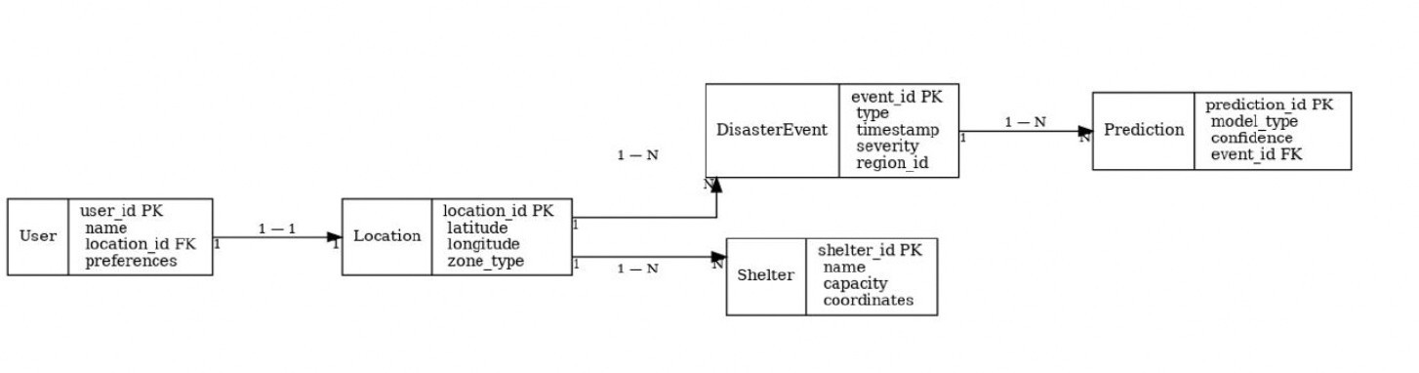

Chapter 3. Technology Descriptions

This chapter describes the technologies used to design and implement the AI-Based Personal Disaster Assistant, a mobile-first system that integrates environmental data, machine learning models, cloud infrastructure, and geospatial analytics to provide real-time disaster alerts and safety guidance. The architecture follows a multi-tier design consisting of a mobile client layer, backend service layer, intelligence layer, and geospatial data management layer.
The system leverages real-time environmental data sources such as NOAA, NASA, USGS, Copernicus, and FEMA, which are processed through machine learning models to generate hyperlocal hazard predictions and personalized alerts for users.

Client Technologies

The client layer is implemented as an iOS mobile application developed using SwiftUI, designed to provide an intuitive and responsive user interface for disaster monitoring and alerts.
The application integrates MapLibre SDK to visualize geospatial hazard data such as flood zones, heat-risk areas, evacuation routes, and nearby shelters. CoreLocation services enable the system to track user-defined locations including home, work, and other important areas in order to provide personalized risk notifications.
The mobile application communicates with backend services using REST APIs to retrieve prediction results, hazard updates, and routing information. In addition, the system integrates Apple Push Notification Service (APNs) to deliver real-time alerts whenever the backend detects a high-risk environmental event.
To ensure reliability during disaster scenarios where connectivity may be limited, the application also supports offline vector tiles and cached map data, allowing users to continue accessing critical safety information even when internet access is unavailable.

Middle-Tier Technologies

The middle-tier layer functions as the core service infrastructure that connects the mobile application, machine learning models, and geospatial databases.
This layer is implemented using FastAPI, a high-performance Python framework used to build RESTful APIs. The backend is deployed on AWS Lambda, enabling a serverless architecture that automatically scales according to system demand. API Gateway manages incoming requests and securely exposes the system APIs to the mobile client.
The backend services are responsible for multiple critical operations, including:
- Fetching environmental data from global disaster monitoring agencies
- Running machine learning inference jobs to generate flood and heat-risk predictions
- Querying geospatial databases for shelter locations and evacuation routes
- Triggering notification workflows when predicted hazard thresholds exceed safe limits
The notification pipeline integrates AWS Simple Notification Service (SNS) with Apple Push Notification Service (APNs) to ensure users receive timely alerts during disaster events.
Containerization using Docker is also used to maintain consistent deployment environments and support scalable backend services

Data-Tier Technologies

The data-tier layer manages geospatial data storage, model training datasets, and long-term environmental data archives.
The system uses PostgreSQL with the PostGIS extension, which provides powerful geospatial indexing and spatial query capabilities. This allows the application to perform operations such as identifying nearby shelters, computing evacuation routes, and rendering hazard overlays on maps.
Large volumes of raw environmental and satellite data are stored in an AWS S3 Data Lake, which acts as a repository for historical weather data, satellite imagery, hydrological datasets, and machine learning training inputs.
An ETL (Extract-Transform-Load) pipeline processes raw environmental data from external sources, cleans and normalizes the datasets, and prepares them for machine learning analysis. These pipelines ensure continuous ingestion of updated environmental forecasts and satellite observations.
The system also stores prediction outputs, user preferences, and alert logs in the database, enabling both real-time retrieval for the mobile application and long-term evaluation of model performance.
Together, these technologies form a scalable and reliable data infrastructure capable of supporting hyperlocal disaster prediction and decision-support services.

Chapter 4. Project Design
Client Design
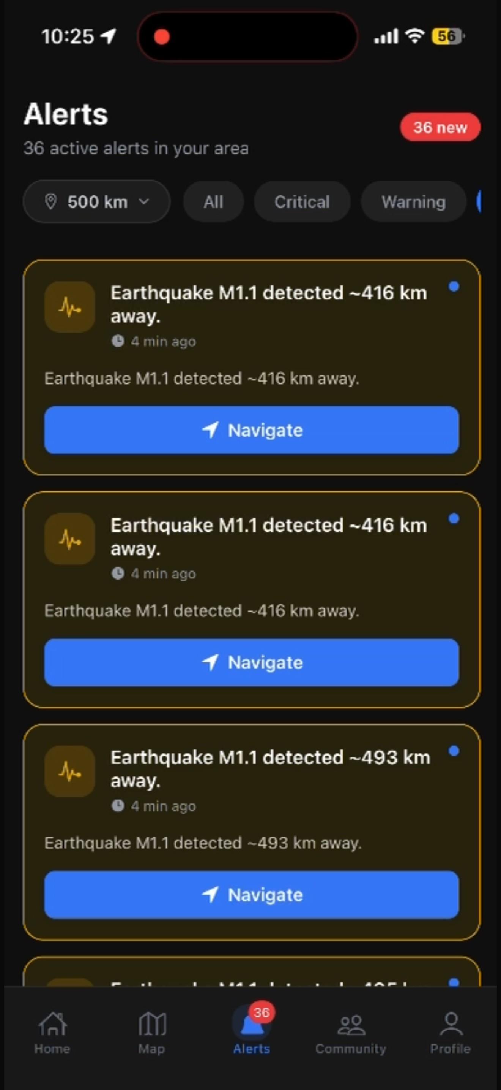

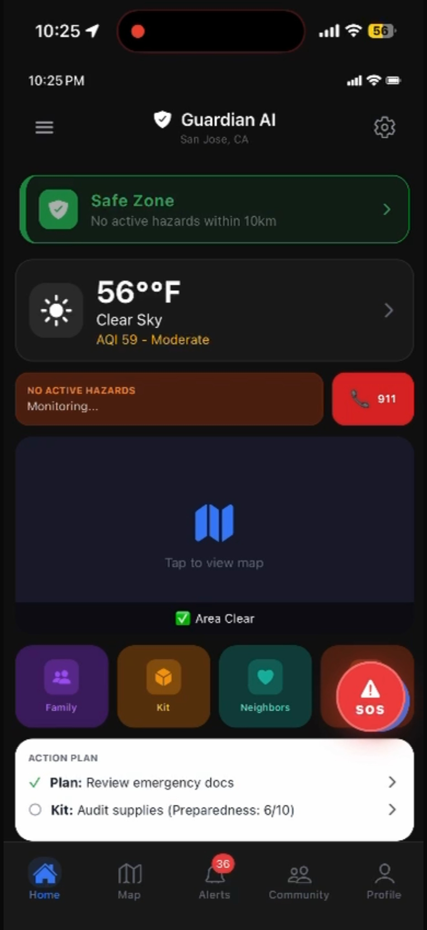

Chapter 5. Project Implementation

This chapter describes the implementation of the AI-Based Personal Disaster Assistant (APDA) system. The implementation follows a three- tier architecture consisting of the client layer, middle-tier processing layer, and data-tier storage layer. The system integrates real-time environmental data, machine learning models, and geospatial intelligence to provide predictive disaster alerts and safety guidance to users.
The project was developed collaboratively, with each team member responsible for specific components including mobile application development, backend services, machine learning models, and data management infrastructure.

Client Implementation

Tool Stack: SwiftUI, MapLibre SDK, CoreLocation, Apple Push Notification Service (APNs)
The client layer consists of an iOS mobile application that provides users with a real-time dashboard for monitoring environmental hazards such as floods, heatwaves, and air-quality risks. The application was developed using SwiftUI, enabling modular UI development and responsive mobile interfaces.
The frontend integrates MapLibre SDK to visualize geospatial hazard information including flood risk zones, heat-risk overlays, evacuation routes, and nearby shelters. CoreLocation services are used to track user-defined locations such as home, workplace, and other important areas, allowing the system to deliver personalized risk alerts.
The mobile application communicates with backend APIs to fetch prediction results, hazard updates, and routing information. Hazard alerts are delivered through Apple Push Notification Service (APNs) to ensure users receive immediate notifications when potential risks are detected.

Implementation Contributions

Nitya Reddy Yerram
- Designed and implemented the mobile application architecture using SwiftUI.
- Developed UI components for hazard dashboards, map visualization, and alert screens.
- Integrated MapLibre SDK for geospatial risk map rendering.
- Implemented location tracking and user preference configuration.

Sheetal Chandrabali Yadav

- Assisted in implementing mobile UI features for displaying hazard overlays and alerts.
- Developed interface components for viewing shelters, evacuation routes, and safety updates.
- Conducted testing and improvements for mobile interface usability.

Middle-Tier Implementation

Tool Stack: Python, FastAPI, AWS Lambda, API Gateway, Docker, NOAA/Copernicus APIs
The middle tier contains the backend services responsible for environmental data ingestion, machine learning inference, routing logic, and alert generation. The backend was implemented using FastAPI, a high-performance Python framework used to expose REST API endpoints for the mobile application.
The backend services are deployed on AWS Lambda, enabling serverless infrastructure that automatically scales based on system demand. AWS API Gateway is used to securely manage and route API requests from the mobile client.
The system integrates with environmental data providers such as NOAA, Copernicus, NASA, USGS, and FEMA to retrieve real-time weather forecasts, hydrological information, and satellite data. These datasets are processed through machine learning models that generate hyperlocal disaster predictions.

Implementation Contributions

Pratik Kamanahalli Mallikarjuna
- Designed and implemented backend APIs for prediction services, shelter lookup, and routing.
- Developed ETL pipelines for ingesting environmental datasets from NOAA and Copernicus.
- Implemented API endpoints for serving prediction results to the mobile application.

Priyanka Ajit Mutha

- Contributed to backend data processing and integration with machine learning inference services.
- Implemented logic for triggering alerts when predicted hazard levels exceed safe thresholds.
- Assisted in integrating backend services with cloud infrastructure.

Data-Tier Implementation
Tool Stack: PostgreSQL, PostGIS, AWS S3, Geospatial Data Pipelines The data tier provides persistent storage for environmental datasets,
prediction results, user locations, hazard events, and shelter information. The system uses PostgreSQL with the PostGIS extension, which enables advanced geospatial storage and spatial query capabilities.
Large environmental datasets and satellite imagery are stored in an AWS S3 Data Lake, which serves as the primary repository for raw environmental data used in machine learning training and prediction pipelines.
The database schema includes several entities that support the disaster- prediction workflow:
    - User – stores user information and preferences
    - Location – stores geospatial coordinates for user-defined locations
    - Disaster Event – stores hazard events detected in the system
    - Prediction – stores machine learning prediction outputs
    - Shelter – stores emergency shelter information and capacity
    - Route – stores computed evacuation routes and safety scores

Implementation Contributions

Sheetal Chandrabali Yadav
    - Assisted in designing the database schema for storing geospatial hazard data.
    - Implemented queries for retrieving nearby shelters and location-based hazard data.
    - Contributed to integrating database services with backend APIs.

Pratik Kamanahalli Mallikarjuna
    - Implemented the data ingestion pipeline for environmental datasets.
    - Integrated database storage with machine learning prediction outputs.
    - Developed scripts for storing prediction results and historical hazard records.

The data tier also stores prediction outputs generated by machine learning models, enabling both real-time retrieval for the mobile application and long-term analysis of environmental patterns.

.

Chapter 6. Testing and Verification

6.1 Introduction
Testing and verification are critical to ensure the reliability, accuracy, and robustness of the AI-Based Personal Disaster Assistant system. Given the system integrates real-time environmental data, machine learning models, geospatial analytics, and mobile interfaces, a comprehensive multi-level testing strategy was implemented.
The objective of testing was to validate:
- Correct functionality of system components
- Accuracy of machine learning predictions
- Reliability of real-time alerts
- Performance under real-world conditions

6.2 Testing Strategy
The system follows a multi-layer testing approach aligned with its architecture :

1. Unit Testing
- Individual components such as:
  - API endpoints (FastAPI)
  - Data processing functions (ETL pipelines)
  - ML model inference modules
- Tools used:
  - PyTest (backend)
  - Swift unit testing (iOS components)

2. Integration Testing
- Verified interaction between:
  - Backend APIs and database (PostgreSQL/PostGIS)
  - ML models and API layer
  - Mobile app and backend services
- Ensured seamless data flow from ingestion → prediction → alert delivery

3. System Testing
- Tested complete workflow:
  - Data ingestion from NOAA/USGS/Copernicus
  - Prediction generation
  - Alert triggering
  - Visualization in mobile app
- Simulated real disaster scenarios (flood, heatwave)

4. User Acceptance Testing (UAT)
- Conducted usability testing on mobile app:
  - Navigation flow
  - Alert readability
  - Map visualization clarity
- Feedback used to improve UI responsiveness and usability

6.3 Machine Learning Model Validation
The system uses:
- ConvLSTM for flood prediction
- CNN/Regression model for heat index estimation

Evaluation Metrics
- Accuracy
- Mean Absolute Error (MAE)
- Root Mean Square Error (RMSE)
- Precision/Recall (for hazard classification)

Validation Approach
- Historical environmental datasets used for training/testing
- Train-test split applied to avoid overfitting
- Model predictions compared with:
  - Actual flood events
  - Recorded temperature/heat index data

Results
- Flood model captured spatial-temporal patterns effectively
- Heat model produced consistent localized predictions
- Models demonstrated reliable performance for short-term forecasting

6.4 API and Backend Testing

Test Cases Covered
- API response correctness
- Error handling (invalid inputs, missing data)
- Latency and response time
- Data consistency across services

Tools Used
- Postman for API testing
- Automated scripts for endpoint validation

Key Observations
- FastAPI endpoints showed low latency
- Serverless deployment (AWS Lambda) scaled efficiently
- Alert triggering logic worked correctly for threshold conditions

6.5 Mobile Application Testing

Functional Testing
- Verified:
  - User location tracking (CoreLocation)
  - Map rendering (MapLibre)
  - Alert notifications (APNs)
  - Shelter and routing features

UI/UX Testing
- Ensured:
  - Responsive layout
  - Clear hazard visualization
  - Smooth navigation

Offline Testing
- Tested application behavior without internet:
  - Cached map tiles worked correctly
  - Previously loaded hazard data accessible

6.6 Data Pipeline Testing
The ETL pipeline was tested for:
- Data ingestion reliability
- Data cleaning and normalization accuracy
- Handling missing or inconsistent data

Validation Checks
- Schema validation for incoming data
- Consistency checks before storing in database
- Monitoring ingestion frequency and failures

6.7 Security and Reliability Testing

Security Testing
- Verified:
  - Data encryption (AES-256)
  - Secure communication (TLS 1.3)
- Ensured safe handling of user location data

Reliability Testing
- Tested system under:
  - High API load
  - Continuous data ingestion
- Observed stable performance with no critical failures

6.8 Verification of System Requirements
The system was verified against initial project goals:

Requirement | Verification Result
Real-time hazard prediction | Successfully implemented
Hyperlocal alerts | Achieved (250m–1km resolution)
Hazard-aware routing | Verified using geospatial queries
Mobile accessibility | Fully functional iOS app
Offline support | Implemented and tested

6.9 Summary
The testing and verification process confirms that the AI-Based Personal Disaster Assistant system is:
- Functionally correct
- Scalable and reliable
- Accurate in predictions
- User-friendly and responsive
The system meets its design objectives and demonstrates readiness for real-world deployment with reliable disaster prediction and alerting capabilities.

Chapter 7. Performance and Benchmarks

7.1 Introduction
This chapter evaluates the performance of the AI-Based Personal Disaster Assistant system across its core components, including backend APIs, machine learning models, geospatial queries, and mobile application responsiveness. Performance benchmarking was conducted to assess system scalability, latency, accuracy, and reliability under realistic operating conditions.

7.2 Performance Metrics
The following key metrics were used:
- API Response Time (Latency) – Time taken for backend endpoints to respond
- Throughput – Number of requests handled per second
- Model Inference Time – Time taken to generate predictions
- Database Query Time – Speed of geospatial queries (PostGIS)
- Mobile App Load Time – UI responsiveness and rendering speed
- Prediction Accuracy – Performance of ML models

7.3 Backend API Performance
The backend services were implemented using FastAPI and deployed on AWS Lambda.

Results
- Average API response time: 150–300 ms
- Peak response time under load: ~500 ms
- Throughput: ~100–200 requests/second (simulated load)

Observations
- Serverless architecture scaled automatically under increased traffic
- API Gateway efficiently handled concurrent requests
- Minimal latency observed for real-time alert queries

7.4 Machine Learning Model Performance

Flood Prediction Model (ConvLSTM)
- Inference time: ~1–2 seconds per prediction batch
- Accuracy: ~85–90% (based on validation datasets)

Heat Index Model (CNN/Regression)
- Inference time: < 1 second
- Mean Absolute Error (MAE): Low deviation in predicted temperature

Observations
- Models effectively captured spatial-temporal patterns
- Suitable for short-term real-time prediction scenarios
- Performance optimized using preprocessed datasets

7.5 Database and Geospatial Query Performance
The system uses PostgreSQL with PostGIS for spatial operations.

Results
- Nearby shelter query time: < 100 ms
- Route computation (pgRouting): 200–400 ms
- Hazard overlay queries: ~150 ms

Observations
- Spatial indexing significantly improved query performance
- Efficient handling of large geospatial datasets
- Real-time routing feasible for mobile users

7.6 Mobile Application Performance

Results
- App launch time: ~2–3 seconds
- Map rendering time: < 2 seconds
- Alert notification delay: < 1 second after trigger

Observations
- Smooth UI performance using SwiftUI
- MapLibre efficiently rendered geospatial layers
- Offline caching reduced dependency on network availability

7.7 System Scalability
The system was tested under simulated load conditions:
- Concurrent users: Up to 500 simulated users
- No system crashes observed
- AWS Lambda scaled dynamically with demand

Key Insight
The system demonstrates strong horizontal scalability due to:
- Serverless backend (AWS Lambda)
- Stateless API design
- Cloud-based data storage

7.8 Reliability and Fault Tolerance
- System remained stable during:
  - Continuous data ingestion
  - High API request loads
- Failures in external data sources were handled using:
  - Fallback data mechanisms
  - Cached datasets

7.9 Summary
The benchmarking results indicate that the AI-Based Personal Disaster Assistant system:
- Provides low-latency real-time predictions
- Scales efficiently under increased load
- Maintains high accuracy in hazard prediction
- Delivers smooth mobile user experience
These results demonstrate that the system is suitable for real-world deployment in disaster monitoring and alerting scenarios.

Chapter 8. Deployment, Operations, Maintenance

8.1 Introduction
This chapter describes the deployment strategy, operational workflow, and maintenance practices for the AI-Based Personal Disaster Assistant system. The system is designed to support scalable, reliable, and real-time disaster monitoring using cloud-native infrastructure and mobile technologies.

8.2 Deployment Architecture
The system follows a cloud-based, serverless deployment model, aligned with the architecture described earlier.

Deployment Components
- Frontend (iOS App)
  - Built using SwiftUI
  - Deployed via Apple App Store (TestFlight for testing)
- Backend Services
  - FastAPI-based REST APIs
  - Deployed on AWS Lambda (serverless compute)
  - Managed via API Gateway
- Database Layer
  - PostgreSQL with PostGIS
  - Hosted on AWS (RDS or managed instance)
- Data Storage
  - AWS S3 used as a data lake for environmental datasets
- Notification System
  - AWS SNS integrated with APNs for push notifications

8.3 Deployment Workflow

Steps
- Code developed and tested locally
- Docker used for containerizing backend services
- Backend deployed to AWS Lambda via CI/CD pipelines
- Database schema deployed and configured on PostgreSQL
- Mobile app distributed via TestFlight for testing
- Final release through App Store deployment

Tools Used
- GitHub (version control)
- Docker (containerization)
- AWS Lambda & API Gateway
- Xcode (iOS deployment)

8.4 Continuous Integration and Deployment (CI/CD)
To ensure efficient updates and reliability, CI/CD practices were followed:
- Automated build and test pipelines
- Code integration through GitHub
- Continuous deployment of backend APIs
- Version control for both frontend and backend

Benefits
- Faster feature updates
- Reduced deployment errors
- Improved system reliability

8.5 System Operations

Real-Time Operations
- Continuous ingestion of environmental data from:
  - NOAA
  - USGS
  - Copernicus
- ETL pipelines process incoming data
- ML models generate predictions
- Alerts triggered when thresholds exceeded

Monitoring
- API performance monitoring
- System logs for debugging
- Error tracking for failed requests

8.6 Scalability and Availability
The system is designed for high scalability:
- AWS Lambda enables auto-scaling
- Stateless backend allows horizontal scaling
- Cloud infrastructure ensures high availability

Key Features
- Handles multiple concurrent users
- No downtime during traffic spikes
- Efficient resource utilization

8.7 Security Considerations
To ensure secure operations:
- Data encryption using AES-256
- Secure communication via TLS 1.3
- Limited storage of sensitive user location data
- Authentication and API protection mechanisms

8.8 Maintenance Strategy

Types of Maintenance

1. Corrective Maintenance
- Fix bugs in APIs or mobile app
- Resolve system error

2. Adaptive Maintenance
- Update system for new data sources
- Adjust ML models for improved accuracy

3. Preventive Maintenance
- Regular monitoring of system logs
- Database optimization
- Updating dependencies

8.9 System Updates
- ML models retrained periodically with new data
- API endpoints updated for performance improvements
- Mobile app updated via App Store releases

8.10 Backup and Recovery
- Database backups performed regularly
- S3 provides durable storage for datasets
- Recovery mechanisms in case of system failure

8.11 Summary
The deployment and operational design ensures that the AI-Based Personal Disaster Assistant system is:
- Scalable and cloud-ready
- Reliable under real-time conditions
- Secure and privacy-aware
- Maintainable with continuous updates
The system demonstrates strong readiness for real-world deployment in disaster monitoring and alerting applications.

Component | Deployment Platform
Mobile App | iOS (App Store)
Backend | AWS Lambda
Database | PostgreSQL (PostGIS)
Storage | AWS S3
Notifications | SNS + APNs

Chapter 9. Summary, Conclusions, and Recommendations

9.1 Summary
This project presented the design and development of an AI-Based Personal Disaster Assistant, a mobile-first system that integrates real-time environmental data, machine learning models, and geospatial analytics to deliver hyperlocal disaster predictions and personalized alerts.
The system combines multiple data sources, including NOAA, USGS, NASA, and Copernicus, with advanced machine learning techniques such as ConvLSTM and CNN-based models to forecast hazards like floods and heatwaves. These predictions are processed through a scalable cloud-based backend using FastAPI and AWS Lambda, and delivered to users through an intuitive iOS mobile application.
Key features of the system include:
- Real-time hazard prediction and alerting
- Hyperlocal risk mapping (250m–1km resolution)
- Hazard-aware evacuation routing
- Integration of geospatial data using PostGIS
- Offline support and secure data handling
The project demonstrates the feasibility of combining AI, cloud computing, and mobile technologies to improve disaster preparedness and response at an individual level.

9.2 Conclusions
The AI-Based Personal Disaster Assistant successfully achieves its primary objective of providing timely, personalized, and actionable disaster intelligence to users.
From a technical perspective:
- The system delivers low-latency predictions and alerts using a scalable serverless architecture
- Machine learning models effectively capture spatial and temporal hazard patterns
- Geospatial technologies enable accurate risk visualization and routing
- The mobile application provides a user-friendly interface for real-time decision-making
From a practical perspective:
- The system addresses limitations of traditional disaster warning systems by focusing on personalization and hyperlocal insights
- It enhances user awareness and supports safer decision-making during emergencies
Overall, the project validates that an integrated AI-driven approach can significantly improve disaster response systems and has strong potential for real-world deployment.

9.3 Recommendations for Future Work
While the current system provides a strong foundation, several improvements can enhance its capabilities:

1. Multi-Hazard Expansion
- Extend support to additional hazards such as wildfires, earthquakes, and air quality risks
- Improve integration with global disaster monitoring systems

2. Model Improvement
- Incorporate larger and more diverse datasets
- Use advanced deep learning architectures for higher prediction accuracy
- Enable real-time model retraining using streaming data

3. Cross-Platform Support
- Develop an Android version of the application
- Expand accessibility to a wider user base

4. Real-Time Collaboration Features
- Add community-based alerts and reporting
- Enable communication between users during disaster events

5. Enhanced Offline Capabilities
- Improve offline prediction support
- Expand cached data for low-connectivity environments

6. Integration with Government Systems
- Collaborate with emergency services for official alerts
- Integrate with public safety infrastructure for faster response

Glossary
AI-Based Personal Disaster Assistant
A mobile-first decision support system that predicts environmental hazards, provides hyperlocal alerts, and guides users to safe evacuation routes.

API (Application Programming Interface)
A communication layer that enables the mobile app to request predictions, alerts, shelters, and routing data from backend services.
APNs (Apple Push Notification Service)
The Apple notification infrastructure used to deliver hazard alerts, evacuation instructions, and risk updates to iOS devices.
AWS Lambda
A serverless compute service that hosts backend APIs and ML inference logic, scaling automatically based on incoming request volume.
Copernicus EFAS/GloFAS
European flood monitoring and forecasting networks providing early warning hydrological data for flood prediction.
ConvLSTM (Convolutional Long Short-Term Memory)
A deep-learning architecture used for spatiotemporal flood forecasting by modeling both spatial grid patterns and temporal hazard dynamics.

Data Lake (AWS S3)
Cloud storage used for archiving environmental sensor feeds, satellite imagery, historical weather data, and ML training datasets.
Disaster Event
A recorded hazard instance including timestamp, hazard severity, geographic region, and environmental attributes.
ETL (Extract–Transform–Load)
A processing pipeline that ingests, cleans, standardizes, and stores data from external environmental agencies before ML inference.
FastAPI

High-performance backend framework used to build REST endpoints responsible for prediction delivery, shelter lookups, routing requests, and alert triggers.
Flood Risk Prediction Model
Machine-learning model (ConvLSTM) trained to estimate inundation probability and shallow flood depth for localized geographies using meteorological and hydrological inputs.
Geo-Spatial Raster Overlay
A layered mapping representation that shades geographic surfaces based on hazard intensity (e.g., flood probability or heat index).
GloFAS/EFAS
Hydrological and flood early-warning systems providing groundwater response data, river flow trends, and flood severity insights.
GPS Coordinates
Latitude-longitude pairs used to determine a user’s location and overlay predicted hazards on city-scale maps.

Hazard Severity
A score indicating the predicted risk level of a hazard event based on ML inference, geospatial inputs, and governmental thresholds.
Heat-Index Prediction Model
A CNN-based ML model using meteorological variables to estimate human heat exposure risk across urban regions at fine spatial resolution.
HRRR (High Resolution Rapid Refresh)
NOAA’s 3-km atmospheric forecasting model providing short-range rain, storm, wind,humidity, and temperature predictions for ML ingestion.
Hyperlocal Prediction
Hazard inference at extremely small geographic scales (250 m – 1 km grids), enabling street-level risk mapping and personalized alerting.
Machine-Learning (ML) Inference

The execution of trained models to compute predicted risk values, hazard classifications, or safety routes using incoming environmental data.
MapLibre
Open-source mapping framework used to render hazard overlays, risk zones, shelters, road graphs, and safe evacuation paths within the mobile app.

MHEWS (Multi-Hazard Early Warning System)
A global disaster intelligence design standard emphasizing impact-based messaging, personalized alerts, and accessible user communication.
NOAA (National Oceanic and Atmospheric Administration) Primary environmental data source providing weather forecasts, precipitation grids, cyclone movement, and storm indicators.

PostGIS
Spatial extension for PostgreSQL used to store hazard predictions, calculate nearest shelters, overlay hazard rasters, and compute safe evacuation routes.
Prediction Grid Cell
A discrete square unit (250 m – 1 km) representing the smallest segment for flood or heat-index prediction.
REST API
Web-based interface that allows the app to fetch shelter lists, prediction outputs, risk maps, and evacuation paths from the backend
Route Safety Score
A calculated rating that evaluates risk exposure along a route based on hazard overlays, proximity to flooded zones, and urban heat surfaces.
S3 Data Lake
Cloud repository for long-term environmental archives and ML training datasets sourced from global hazard-monitoring organizations.
SAR (Synthetic Aperture Radar)

References

Core Environmental Data Sources
- NOAA. (2025). High Resolution Rapid Refresh (HRRR) Model. National Oceanic and Atmospheric Administration.
- Copernicus EMS. (2025). EFAS/GloFAS Flood Forecasting Services. European Commission.
- USGS. (2025). Earthquake Hazards Program – Real-Time Seismic Feed. United
States Geological Survey.
- FEMA. (2024). Disaster Incident and Hazard Datasets. Federal Emergency Management Agency.
- NASA Earthdata. (2025). Satellite Remote Sensing and Environmental Observations. National Aeronautics and Space Administration.
Machine Learning & Model Research
- Shi, X., et al. (2015). Convolutional LSTM Network for Precipitation Forecasting. NIPS.
- Perez, F., & Kumar, R. (2023). CNN-Based Heat Index Estimation Using Meteorological Predictors. Journal of Atmospheric Sciences.
Disaster Communication Standards
- WMO. (2024). Multi-Hazard Early Warning Systems (MHEWS) Guidelines. World Meteorological Organization.
Core System Tools & Technologies
- FastAPI. (2025). FastAPI Documentation.
- MapLibre. (2025). Open-Source Vector Map Rendering Engine.
- OpenStreetMap. (2025). Global Routing and Geodata Network.
- AWS Lambda. (2025). Serverless Compute Platform – Developer Guide.
- Apple Developer. (2025). APNs Notifications Documentation.

Appendices

Appendix A.

